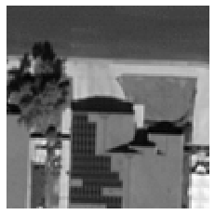

1. Greyscaled image

(c) Binary thresholding. Here we can see darker areas including the solar panels become black.

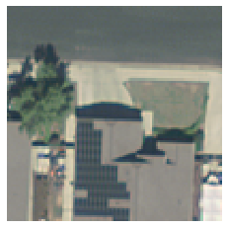

1. Original image

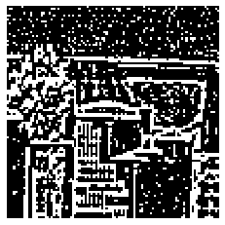

1. Adaptive thresholding. Solar panel pattern is more evident than binary thresholding.

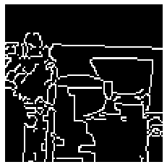

(e) Canny edges. Rectangular shape of solar pattern is only somewhat evident.

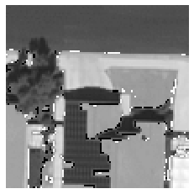

1. Weighted blurring of grayscaled image, binary thresholding, and Otsu thresholding. Here the solar panel is clearer without as much loss in pattern or color darkness.

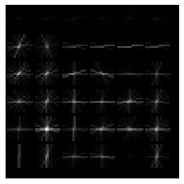

1. HOG. The HOG output shows edges and areas with large changes in intensity.
2. Greyscaled image
3. Original image